Aging Analysis Results

Intro:

The widespread availability of effective antiretroviral therapy (ART) has substantially increased the life expectancy of people with HIV in the United States. The consequent rise in prevalence may lead to aging of the population of PWH and a shift in age-related comorbidities needing support by healthcare systems and their funding structures. In this study, we use a mathematical model of HIV transmission to project changes in the age distribution of PWH in 11 U.S. states.

*Further ideas for introduction:*

Methods:

The Johns Hopkins Epidemiologic and Economic Model (JHEEM) is a dynamic HIV transmission model3. We used the model to simulate HIV epidemics in Alabama, California, Florida, Georgia, Illinois, Louisiana, Mississippi, Missouri, New York, Texas, and Wisconsin, where 63% of people diagnosed with HIV in the US reside, as described in *. Calibration targets for this study include local epidemiologic targets such as new diagnoses and diagnosed prevalence by age.

*For paper:*

*Model structure, study setting, calibration, model outcomes, secondary analyses (explaining state variation), sensitivity analyses*

*For our group:*

* *Model outcome (delta prop 55+, also median age)*

|  |  |  |  |  |  |  |  |  |  |  |
| --- | --- | --- | --- | --- | --- | --- | --- | --- | --- | --- |
| **Measure** | **Total** | **Proportion Age 55+** | | | **Number Age 55+** | | | **Median Age** | | |
| *Year* | *2025* | *2025* | *2040* | Δ | *2025* | *2040* | Δ | *2025* | *2040* | Δ |
| *CA* | 140,514 | 50% | 67% | 17% | 70,024 | 89,408 | 19,384 | 54 | 67 | 13 |
|  | [47 to 53%] | [59 to 75%] | [11 to 24%] | [65,956 to 74,277] | [78,383 to 100,109] | [11,274 to 27,031] | [52 to 56] | [63 to 70] | [11 to 16] |
| *FL* | 126,261 | 51% | 65% | 14% | 64,700 | 91,496 | 26,796 | 55 | 65 | 10 |
|  | [48 to 54%] | [56 to 75%] | [7 to 22%] | [61,181 to 68,566] | [80,767 to 106,063] | [18,299 to 37,780] | [53 to 57] | [60 to 70] | [6 to 14] |
| *NY* | 122,642 | 56% | 65% | 9% | 68,852 | 74,912 | 6,060 | 58 | 67 | 8 |
|  | [54 to 58%] | [58 to 72%] | [3 to 16%] | [65,678 to 71,994] | [66,824 to 84,789] | [-676 to 14,310] | [57 to 60] | [63 to 70] | [6 to 11] |
| *TX* | 107,200 | 36% | 47% | 11% | 38,685 | 59,400 | 20,715 | 46 | 49 | 3 |
|  | [34 to 38%] | [39 to 58%] | [4 to 20%] | [35,915 to 41,236] | [50,022 to 71,931] | [13,258 to 31,171] | [45 to 47] | [42 to 61] | [-3 to 14] |
| *GA* | 63,841 | 37% | 45% | 8% | 23,875 | 32,831 | 8,957 | 45 | 47 | 2 |
|  | [34 to 41%] | [35 to 58%] | [-1 to 17%] | [21,933 to 26,114] | [25,816 to 39,222] | [3,603 to 14,183] | [44 to 47] | [41 to 64] | [-4 to 17] |
| *IL* | 35,682 | 43% | 56% | 14% | 15,209 | 17,807 | 2,598 | 48 | 59 | 11 |
|  | [40 to 46%] | [47 to 70%] | [6 to 24%] | [14,206 to 16,345] | [15,471 to 20,933] | [516 to 4,859] | [47 to 50] | [46 to 68] | [-2 to 18] |
| *LA* | 22,298 | 39% | 52% | 13% | 8,637 | 12,937 | 4,299 | 47 | 54 | 7 |
|  | [36 to 42%] | [40 to 65%] | [4 to 24%] | [7,909 to 9,406] | [10,189 to 16,089] | [2,252 to 6,750] | [45 to 48] | [43 to 65] | [-3 to 17] |
| *AL* | 15,021 | 34% | 33% | -1% | 5,045 | 6,150 | 1,105 | 44 | 41 | -3 |
|  | [30 to 37%] | [25 to 47%] | [-6 to 10%] | [4,570 to 5,474] | [4,767 to 8,168] | [47 to 2,886] | [43 to 46] | [38 to 46] | [-5 to 1] |
| *MO* | 13,812 | 43% | 47% | 3% | 5,964 | 7,366 | 1,402 | 48 | 48 | -1 |
|  | [40 to 47%] | [35 to 59%] | [-5 to 14%] | [5,473 to 6,456] | [6,015 to 8,672] | [429 to 2,381] | [46 to 51] | [39 to 64] | [-8 to 14] |
| *MS* | 10,154 | 38% | 44% | 6% | 3,853 | 5,292 | 1,439 | 47 | 47 | 0 |
|  | [35 to 41%] | [38 to 53%] | [2 to 13%] | [3,532 to 4,172] | [4,325 to 6,461] | [744 to 2,342] | [46 to 48] | [43 to 57] | [-3 to 10] |
| *WI* | 7,259 | 44% | 43% | -1% | 3,185 | 4,221 | 1,036 | 49 | 41 | -7 |
|  | [41 to 47%] | [37 to 53%] | [-6 to 7%] | [2,976 to 3,409] | [3,700 to 4,774] | [664 to 1,461] | [47 to 51] | [38 to 60] | [-10 to 10] |
| *Total* | 664,684 | 46% | 57% | 11% | 308,028 | 401,820 | 93,791 | 51 | 61 | 10 |
|  | [45 to 47%] | [54 to 60%] | [8 to 14%] | [301,733 to 314,764] | [379,206 to 425,756] | [75,052 to 113,903] | [51 to 52] | [58 to 63] | [7 to 12] |

Figure 1. Diagnosed prevalence projections by state.

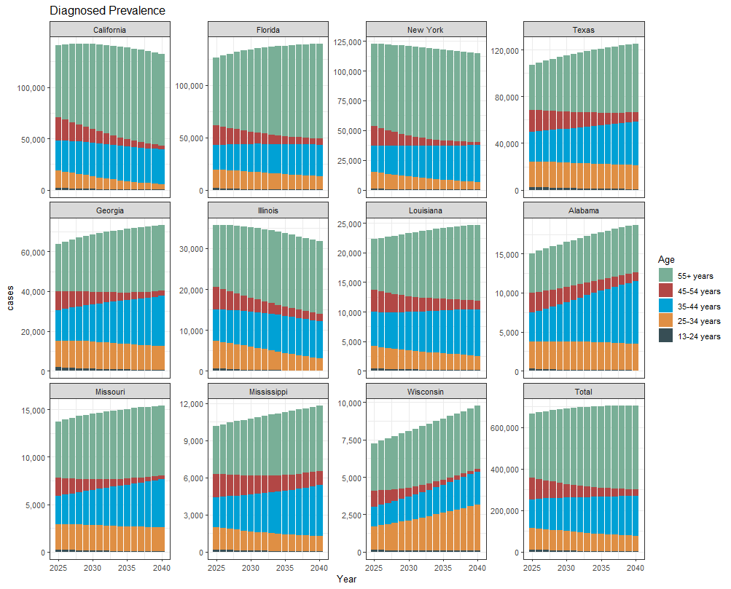

Figure 2. Diagnosed prevalence projections stratified by age group.

The model projected the total number of PLWH age 55+ in the region to rise by 93,791 (CI: 75,052 to 113,903) between 2025 and 2040, an approximately 30% increase. The proportion of PLWH who are age 55+ was projected to rise by 11 percentage points from just under half of the diagnosed population (46%; CI: 45 to 47%) to 57% of the diagnosed population (CI: 54 to 60%). The median age of PLWH in the region was projected to rise by 10 years (CI: 7 to 12). The proportion of MSM who are 55+ was projected to increase from 43% (CI: 41 to 44%) in 2025 to 53% (CI: 49 to 58%) in 2040, while the same proportion for non-MSM individuals began and remained higher, rising from 53% (CI: 52 to 55%) in 2025 to 65% (CI: 60 to 70%) in 2040. Among our three modeled racial categories, “Black” and “Hispanic” began younger than “Other”, but all three aged significantly. The proportion of Black individuals who are 55+ was projected to rise from 41% (CI: 40 to 43%) in 2025 to 50% (CI: 46 to 55%) in 2040, while the similar proportion for Hispanic individuals was projected to rise from 42% (CI: 40 to 45%) in 2025 to 59% (52 to 66%) in 2040, and for Other race individuals, from 59% (CI: 57 to 60%) in 2025 to 66% (CI: 62 to 70%) in 2040.

Most states projected aging populations, although there was some variation. California, which currently has the highest number of diagnosed cases within the eleven states, aged the most, with the proportion of PLWH age 55+ rising by 17 percentage points (CI: 11 to 24) and median age shifting 13 years older (CI: 11 to 16). Florida and Illinois aged nearly as much, with the proportion age 55+ rising by 14% (CI: 7 to 22%) and 14% (CI: 6 to 24%), respectively. By contrast, Alabama and Wisconsin’s populations of PLWH were not projected to age, with the proportion age 55+ staying nearly constant (AL: -1%, CI -6 to 10%; WI: -1%, CI -6 to 7%) and median age decreasing by a few years (AL: -3, CI -5 to 1; WI: -7; CI -10 to 10). Most states showed a persistently bimodal age distribution, with the majority of prevalent cases existing in either the 55+ or 35-44 years age categories (Fig 2). Wisconsin was an exception, with 25-34 years becoming the second-largest age category by 2040 with 32% of prevalent cases.­­

*Sensitivity analyses explaining state variation*

Total: 665,000 (CR: 658,000 to 671,000) in 2025 to 702,000 (CR: 673,000 to 726,000) in 2040.

The model projected the number of PLWDH in the 11-state region to rise from 665,000 (CR: 658,000 to 671,000) in 2025 to 702,000 (CR: 673,000 to 726,000) in 2040, of which those over the age of 55 years numbered 308,000 (CR: 302,000 to 315,000) in 2025 and 402,000 (CR: 379,000 to 326,000) in 2040. This reflected an increase in the proportion of PLWDH who are aged 55 or old from 46% (CR: 45 to 47%) in 2025 to 57% (CR: 54 to 60%) in 2040 and a shift in median age of PLWDH from 51 years (CR: 51 to 52) to 61 years (CI: 58 to 63).

Discussion:

P1 is a summary of main results.

Middling paragraphs situate it in context of other papers

P on limitations

P on strengths (usually smaller than limitations)

PLast is an even briefer summary with a punchy ending of the significance.